eTap2hw echo unit.

Looking at the unit from the rear, the right jack socket is the input and the left is the output.
From the front, the 2 LEDs indicate that the power is on ( greeny/blue) and that the signal is clipping (red)
The left hand thumbwheel switch has, from 0 to 7 , 8 programs that emulate various echo machines. 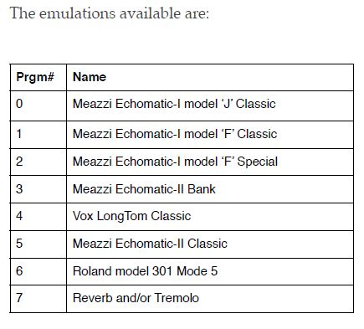
The black headed knob next to it controls the level of input to the unit, this is also the on/off switch, rotating clockwise to turn the unit on.
Next to that is the red headed knob , this in most cases controls the dry/wet mix of direct to echo signal. Dry anticlockwise and full echo clockwise.
Next to that is the yellow headed knob. In most case this controls the selection of feedback patterns exactly as per the Meazzi machines. 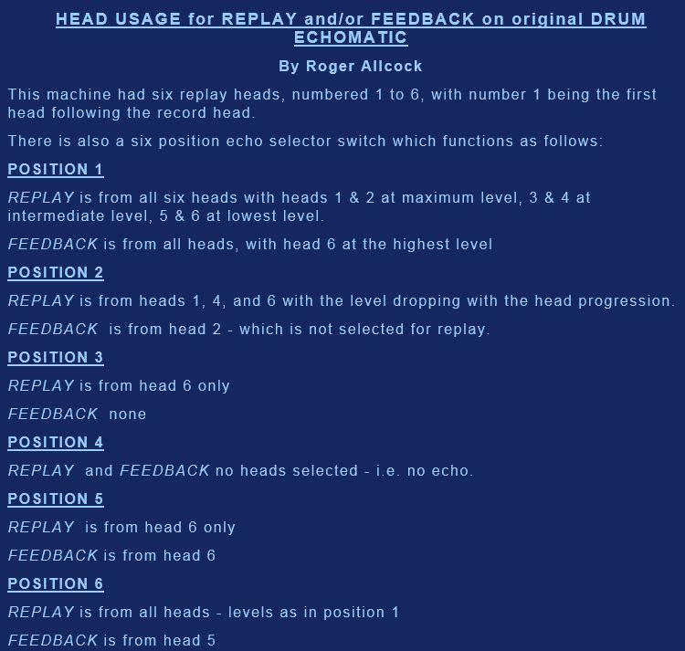
On this unit there is no facility for position 4. i.e. no echo at all.
To achieve these settings the yellow knob should be rotated slowly clockwise from its extreme anticlockwise position through the 5 positions that correspond to the Meazzi switch. This will be at intervals of its rotation approx; 0 to 2, 2 to 4, 4 to 6, 6 to 8,8 to 10, 10 to 12. This will be heard.
The right hand grey/blue knob is in most cases the feedback level control.
With the thumbwheel switch at position 5 the controls act differently, The red knob controls the levels of heads 1,2 and 3 and the yellow knob controls the level of head 4.
On position 6 the yellow knob controls the speed of the Roland echo’
On position 8 the red knob controls the reverb level, the yellow knob the Trenolo frequncy and the grey/blue knob control the tremolo depth.
Below is the table of all the attributes of the various controls.
The description POT0 refers to the red knob, POT1 The yellow knob and POT2 is the grey/blue knob.



